Status of This Document

Version History
Ver. No. | Date | Revised By | Description | Filename
0.1 | 31 October 2005 | KO Chiu | Initial draft | Hermes 2 Installation Guide.doc
0.2 | 11 November 2005 | KO Chiu | Partnership maintenance and loop back test section added | Hermes 2 Installation Guide 0_2.doc
0.3 | 17 November 2005 | KO Chiu | Updated the description | Hermes 2 Installation Guide 0_3.doc
0.4 | 28 November 2005 | Ronnie Kwok | Content revise | Hermes 2 Installation Guide 0_4.doc
0.5 | 23 May 2007 | Twinsen Tsang | Content revise for new H2O | Hermes 2 Installation Guide 0_5.doc
0.6 | 29 May 2008 | Philip Wong | Change instruction of loopback test | Hermes 2 Installation Guide.doc
0.7 | 1 Aug 2008 | Patrick Yip | H2O installer update and web service usage sample is included | Hermes 2 Installation Guide.doc
0.8 | 30 Jan 2009 | Steve Chan | Added tomcat-user and partnership configuration  Added JDK 1.6 & Tomcat 6.0 Support  Updated references | Hermes 2 Installation Guide.doc
0.9 | 8 Jan 2010 | Jumbo Cheung | Updated to lastest installer screen  Added section to explain Message Signing and Secure Channel | Hermes 2  Installation  Guide.doc

Table of Contents
Status of This Document 2
Status of This Document 2
1.1. Version History 2
2. Table of Contents 3
3. Procedures 4
3.1. Introduction 4
3.2. Prerequisite 4
3.3. Step 1 – Environment setup 5
3.4. Step 2 – Configuration 5
3.4.1. Database 5
3.5. Step 4 – Start Hermes 2 14
4. Partnership Maintenance and Web Service Usage Sample 16
4.1. Directory Organization 16
4.2. Preparation 16
4.2.1. Windows environment 16
4.2.2. UNIX environment 16
4.3. Partnership Maintenance 16
4.3.1. Creating AS2 Partnership 17
4.3.2. Creating AS2 Plus Partnership 18
4.3.3. Creating ebMS Partnership 18
4.4. Web Service Usage Sample Flow 20
4.4.1. AS2 Web Service Usage Sample 20
4.4.2. ebMS Web Service Usage Sample 23
5. Configuration for Secure Messaging & Secure Channel 26
5.1. Message Signing 26
5.1.1. Sender Setting for Message Signing 27
5.1.2. Receiver Setting for Message Signing 28
5.2. Message Tranfer with Secure Channel 28
6. FAQ 29
6.1. Hermes 2 Deployment 29
6.2. Web Service Usage Sample 29
7. Reference 31

Procedures
This document is to describe how to install and run open-source business-to-business messaging gateway Hermes 2.0 (codenamed Corvus).

Introduction
The application is packaged in the form of a self-extracted java archive (JAR). Upon proper invocation, you will see an installation wizard, either in graphical or text format. Following through the steps will have the following components installed,
- Hermes 2 Core
- Hermes 2 plugins

- Database tables of Hermes 2 plugins for either one of the following database:
  - Postgres 8.0 or later
  - Oracle 9i or later
  - MySQL 5.0 or later with InnoDB storage engine supported
- Web service usage sample

Prerequisite
- Java 2 SDK version 5.0 or above
- A security patch, Java Cryptography Extension (JCE) Unlimited Strength Jurisdiction Policy Files, is also required for the java cryptography extension.
- Tomcat 5.5 or above with port 8080, TOMCAT_HOME is used for referring to the home directory of tomcat in the remaining parts of document.
Note: To access the admin page, you will need to have a Tomcat user with an admin role. One way is to define the user in "tomcat-users.xml". Please refer to the Realm Configuration section in the Tomcat documentation for more details.
*Sample:
Tomcat-users.xml
<?xml version='1.0' encoding='utf-8'?>
<tomcat-users>
<role rolename="tomcat"/>
<role rolename="admin"/>
<user username="corvus" password="corvus" roles="tomcat,admin"/>
</tomcat-users>
- One of the following database installed on any server:
  - PostgreSQL 8.0 or later, POSTGRES_HOME is referring to the home directory of PostgreSQL in the remaining parts of the document.

  - MySQL 5.0 or later, MYSQL_HOME is referring to the home directory of MySQL in the remaining parts of the document.
  - Oracle 9i or later, ORACLE_HOME is referring to the home directory of Oracle in the remaining parts of the document.

Step 1 – Environment setup
Install all the prerequisite items. It is assumed that they are all running on the same machine in the rest of this guide.

Step 2 – Configuration

Database

Postgres
- Create database user with username "corvus" and password "corvus".
  - Open a command prompt
  - Go to POSTGRES_HOME/bin
  - Type "createuser -A -d -P -U <postgres_admin>" where <postgres_admin> representing the name of administrator / super-user in PostgreSQL database. This value is "postgres" if not specified. It may require super user or Postgres owner to execute in Linux.
  - Create a user named "corvus"
  - Enter the password "corvus""
  - Enter the password again for confirmation
  - Enter “n” for question “Shall the new role be allowed to create more new roles?”
  - Enter the PostgreSQL administrator password for creating a new user role.
- Create two databases named "as2" and "ebms" with "corvus" user
  - Open a command prompt
  - Go to POSTGRES_HOME/bin
  - Type "createdb –U corvus –W as2"
  - Enter the password "corvus"
  - Repeat 2.3 - 2.4 for ebms database.

MySQL
- Create two database named “as2” and “ebms” with username “corvus” and password “corvus”.
  - Open a command prompt
  - Go to MYSQL_HOME/bin
  - Type “mysql –u <mysql_admin> -p" where <mysql_admin> representing the name of administrator / super-user in mySQL database. This is "root" by default. It may require super user or mySQL owner to execute in Linux.
  - Enter
  - command below to create as2 database. Notice that specifying collate to “latin1_general_cs” is essential.
create database as2 collate=latin1_general_cs;
  - Enter command below to create and assign access privileges to user “corvus”.
grant all on as2.* to ‘corvus’@’localhost’ identified by ‘corvus’;
  - Repeat 1.4 – 1.5 for ebMS database.

Oracle

For Oracle database creation, since it involve a number of steps and custom parameters for different requirement for the database server. We propose the following reference for the guideline of creating an Oracle database for Hermes 2:

http://www.peacetech.com/flipper/oracle9i/901_doc/server.901/a90117/create.htm

Step 3 – Hermes 2 Deployment

- In Windows platform, open a command prompt and type "java –jar hermes2_installer.jar" or if java is not set in your environment path, specify the full path.
- In Unix/Linux platform, open xterm and follow the same procedure as above.
OR
- In Windows platform, you can execute by double-click or right-click on the .jar file and selecting "open with" and choosing javaw (located where you installed java, in the bin folder).
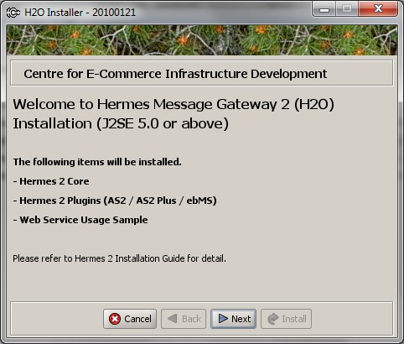
- Click next until you get to Step 1 of the installation.

- Step 1 - Configure Hermes 2 Core:
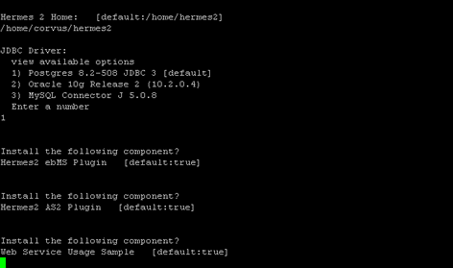
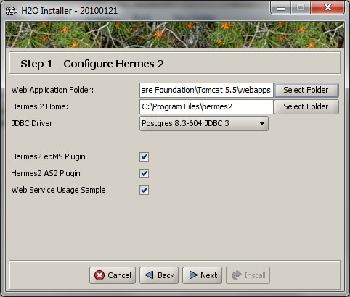

Setting description
Web Application Folder | Folder to place the web application (e.g. webapps) in Tomcat
Hermes 2 Home | Location to place the Hermes 2 core library and some related files
JDBC Driver | Specify which database vendor to connect to  One of these 3 database vendors can be chosen:  - Postgres  - Oracle  - MySQL
Hermes 2 ebMS Plugin | Whether to install the ebMS component
Hermes 2 AS2 Plugin | Whether to install the AS2 component
Web Service Usage Sample | Whether to install the sample program of web service client

- Click next and press yes if the installer prompts you to create a new directory.

- Step 2 - Configure Database for ebMS Plugin (Optional)
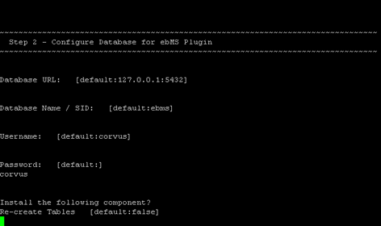
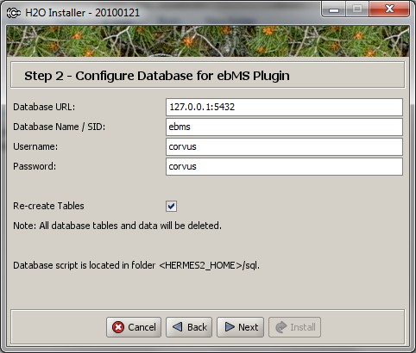

Setting description
Database URL | The URL address of the database server located. Port number may attached to the address as the format <host_address>:<port> where <host_address> is the address of the database server and <port > is the port number of the database server address
Database Name / SID | For Postgres and MySQL, please specify the name of the database. For Oracle, please specify the Oracle System ID (SID)
Username | Username to access database
Password | Password to access database
Re-create Tables | Whether to re-create all the table in the specified database  Important Notes:  If this is your first time to install hermes, please check this option.  If choose to re-create the tables, all of the existing data in the specified database will remove at the later step of installation. Please backup all the data on the selected database before choose to re-create tables.

- If you followed the prerequisite install procedures from above, you can just leave it as the default.
- Then click next.
- If AS2 Plugin was not selected, click next and then click on install and you’re done!

- Step 3 – Configure Database for AS2 Plugin (Optional)
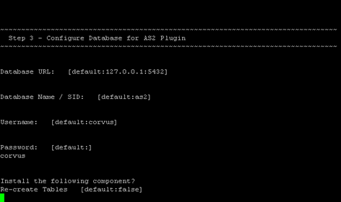
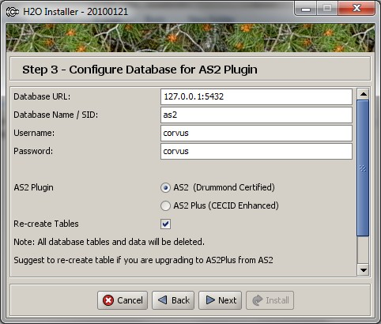

Setting description
Database URL | The URL address of the database server located. Port number may attached to the address as the format <host_address>:<port> where <host_address> is the address of the database server and <port> is the port number of the database server address
Database Name / SID | For Postgres and MySQL, please specify the name of the database. For Oracle, please specify the Oracle System ID (SID)
Username | Username to access database
Password | Password to access database
AS2 Plugin | AS2 : Original AS2 plugin certified by Drummond Group Inc.  AS2 Plus: Built based on AS2 plugin with new/enhanced features.
Re-create Tables | Whether to re-create all the table in the specified database  Important Notes:  If this is your first time to install hermes, pleas check this option.  If you purposely switch your plugin from AS2 to AS2 Plus, or versus. We highly recommend you checked this option.  If choose to re-create the tables, all of the existing data on the specified database will remove at the later step of installation. Please backup all the data on the selected database before choose to re-create tables.

- sername, password and whether to recreate the AS2 database

- If you followed the prerequisite install procedures from above, you can just leave it as the default.

- Then click next and then click on install and you’re done!

Step 4 – Start Hermes 2
Check list:
- Java 2 SDK 5.0 or above with Java Cryptography Extension (JCE) Unlimited Strength Jurisdiction Policy Files 5.0.
- Apache Tomcat 5.5 or above Servlet/JSP Container
- Database server is running with ebMS/AS2 database instance and tables created.
- If you are running Unix/Linux, make sure that at least read permissions are set to the core directory and read/write for AS2 repository directory in Hermes 2 Home.
- Start Tomcat.
- To verify Hermes 2 is running, access the following URL from browser.
- http://localhost:8080/corvus/home

Welcome page should be displayed as below:
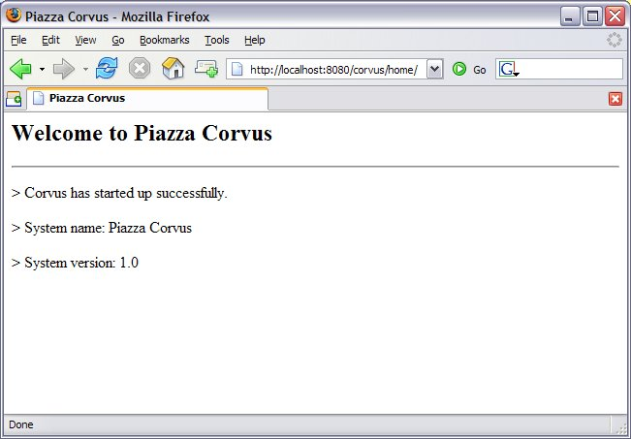

- To access the admin page, go to the following URL. The login user and password is the same as the Tomcat user with admin privileges specified in Section 3.2.
http://localhost:8080/corvus/admin/home

- Once you have gained access to the admin page, you should see the Hermes 2 Administration Console page like this:

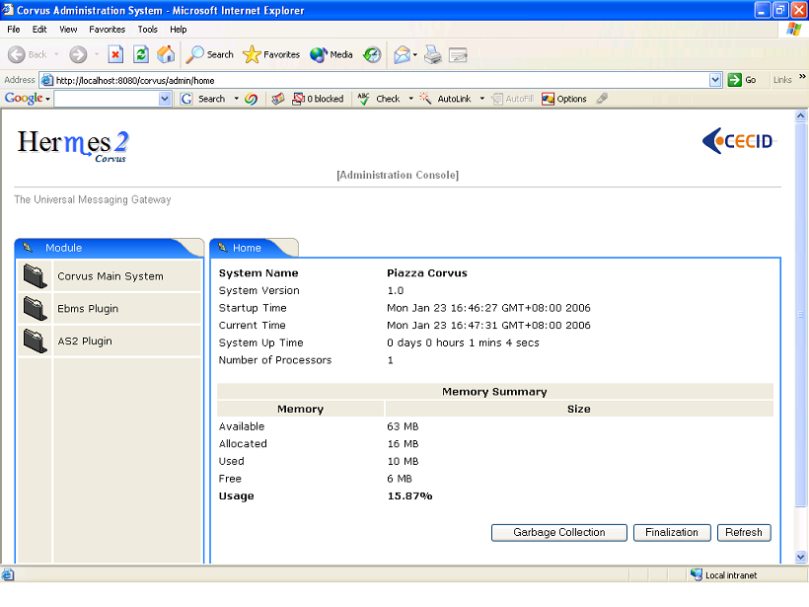
That’s it! Your Hermes 2 should now be up and running. You can test your setup by running our web service usage sample in Section!.

Partnership Maintenance and Web Service Usage Sample

A tool kit called Web Service Usage Sample was installed under Hermes 2, “<HERMES2_HOME>/sample” folder. It contains tools to test the installed Hermes, demonstrate messaging flow and provided a set of sample code for user to write web service client application to connect to the Hermes 2.

Directory Organization
Directory / File | Description
config/* | Contains the configuration file for the sample programs. The folders inside this directory contain related files for specific sample program.
config/ ebms-partnership.xml  and  as2-partnership.xm | These two files contain the setting of the partnership for ebMS and AS2 commonly used by sample programs.
logs/* | A set of logs contains the output from each sample program.
lib/* | The library files required for the sample programs.
*.bat / *.sh | The scripts for executing the sample programs.

Preparation

Windows environment
- Set environment variable JAVA_HOME to the directory installed the java.

UNIX environment
- Set environment variable JAVA_HOME to the directory installed the java.
- Change the permission of all shell-script files to 755 by following command.
chown 755 *.sh

Partnership Maintenance
Users need to define a "Partnership", which contains the relationship of messaging in transport level between a sender and a recipient. It is required to specify the "Partnership" in sender the recipient.
A web service sample program is provided to manage "Partnership" (to add, update or delete). Partnership configuration for AS2/ebMS loopback test is placed in <HERMES2_HOME>/sample/config/as2(ebms)-partnership.xml.

Usage:
as2-partnership  ebms-partnership | Maintain a specified AS2 / ebMS partnership in Hermes 2.

:

Creating AS2 Partnership
To create the partnership required to perform the AS2 messaging loopback test using Web Service Usage Sample in next step, you just need to execute the following command.
as2-partnership

OR

Access http://localhost:8080/corvus/admin/as2/partnership to configure the partnership manually. Below is a simple loop-back configuration sample.

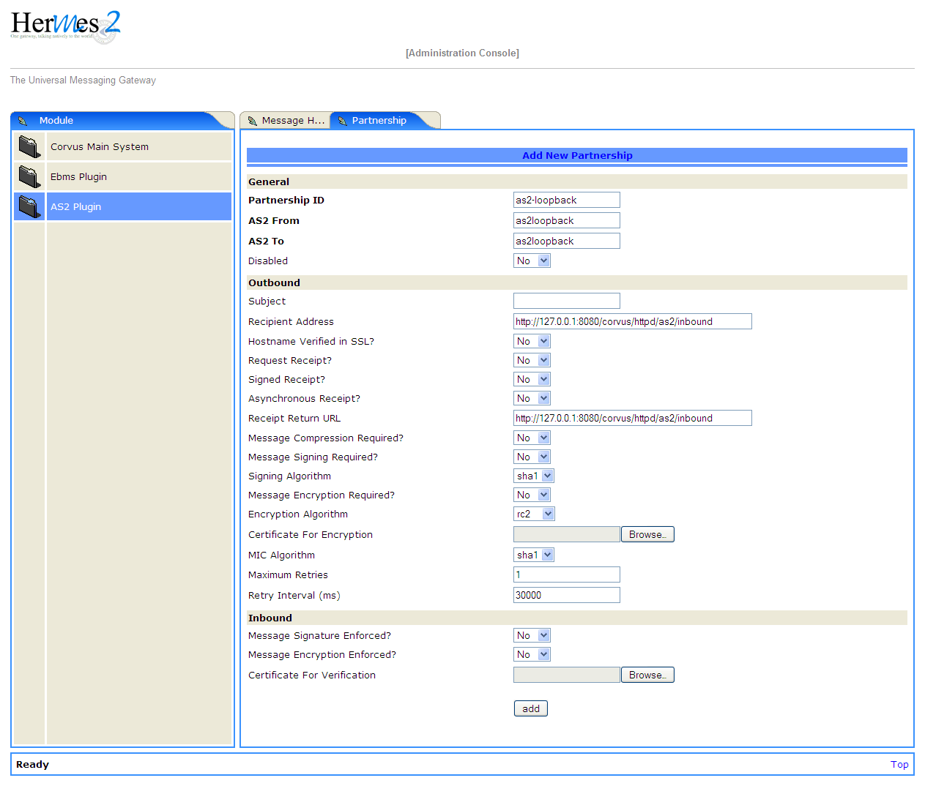

Partnership ID | as2-loopback
AS2 From | as2loopback
AS2 To | as2loopback
Disabled | No
Subject
Recipient Address | http://127.0.0.1:8080/corvus/httpd/as2/inbound
Hostname Verified in SSL? | No
Request Receipt? | No
Signed Receipt? | No
Asynchronous Receipt? | No
Receipt Return URL | http://127.0.0.1:8080/corvus/httpd/as2/inbound
Message Compression Required? | No
Message Signing Required? | No
Signing Algorithm | sha1
Message Encryption Required? | No
Encryption Algorithm | rc1
Certificate For Encryption | none
MIC Algorithm | sha1
Maximum Retries | 1
Retry Interval (ms) | 30000
Message Signature Enforced? | No
Message Encryption Enforced? | No
Certificate For Verification | none

Creating AS2 Plus Partnership
Please reference the procedures of section 4.3.1 to create AS2 Plus partnership.

Creating ebMS Partnership
To create the partnership required to perform the ebMS messaging loopback test using Web Service Usage Sample in next step, you need to execute the following command.
ebms-partnership

OR

Access http://localhost:8080/corvus/admin/ebms/partnership to configure the partnership manually. Below is a simple loop-back configuration sample.

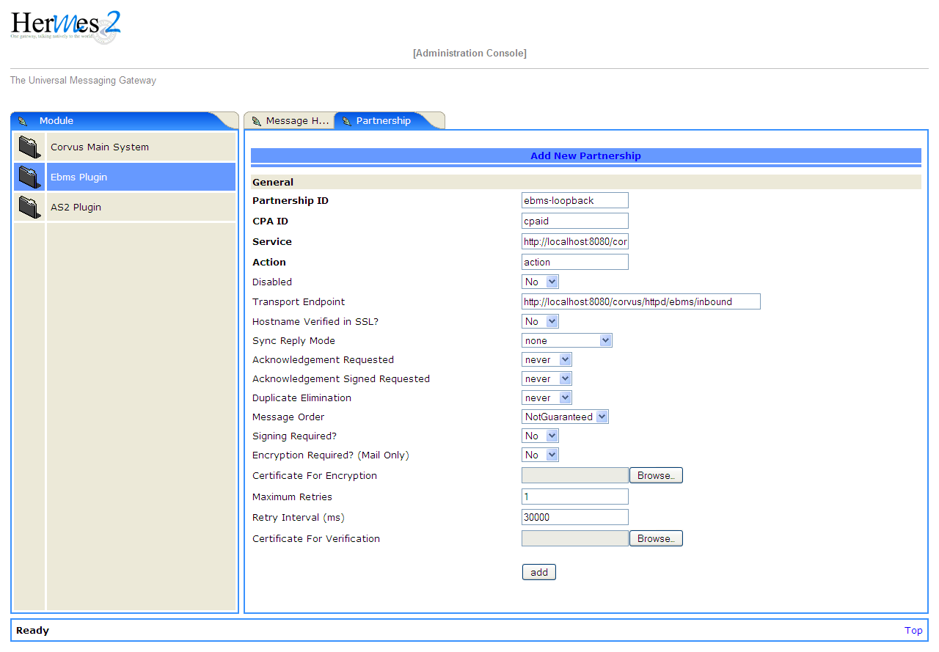

Partnership ID | ebms-loopback
CPA ID | cpaid
Service | http://localhost:8080/corvus/httpd/ebms/inbound
Action | Action
Disabled | No
Transport Endpoint | http://localhost:8080/corvus/httpd/ebms/inbound
Hostname Verified in SSL? | No
Sync Reply Mode | none
Acknowledgement Requested | never
Acknowledgement Signed Requested | never
Duplicate Elimination | never
Message Order | NotGuaranteed
Signing Required? | No
Encryption Required? (Mail Only) | No
Certificate For Encryption | none
Maximum Retries | 1
Retry Interval (ms) | 30000
Certificate For Verification | none

Web Service Usage Sample Flow

In order to validate the installation of Hermes 2, a web service usage sample program is provided. It can be simply executed by running the following command in a command prompt.

Usage:

as2-send  ebms-send | Send a AS2 / ebMS message to the local Hermes 2. installed
as2-history  ebms-history | Show the message history in the Hermes 2. This program will list the inbox and outbox message stored in the Hermes 2 data storage. User can view the details of inbox and outbox. For inbox message, user can also download the payload received in the Hermes 2 repository, if it is available.

In order to test whether the Hermes 2 are installed success or not, we suggest to run sample programs in following steps:
- Add a partnership by running ebms-partnership / as2-partnership.
- Send message to the local Hermes 2 by running ebms-send / as2-send.
- Check the status of sent message by running ebms-history / as2-history and select the message from outbox.
- Check the received message by running ebms-history / as2-history and select the message from inbox, download the payload.

AS2 Web Service Usage Sample
You are required to execute section 4.3.1 successfully before executing the following AS2 web service usage sample. Next we illustrate the steps to run the test described in section 4.4

Send message to the local Hermes 2
as2-send

This program creates and sends the request attached with payload named " testpayload" under the directory "/config/as2-send" to Hermes2.
Upon successful execution, you should be able to see the similar output shown as follow:

----------------------------------------------------
AS2 Message Sender
----------------------------------------------------
Initialize Logger ...
Importing AS2 sending parameters ... ./config/as2-send/as2-request.xml
Importing AS2 partnership parameters ... ./config/as2-partnership.xml
Initialize AS2 message sender...
Adding payload in the AS2 message...
Sending AS2 sending request ...

Sending Done:
----------------------------------------------------
New message id: 20080722-133931-01300@127.0.1.1

Please view log for details ..

Check the sent message
as2-history
This program retrieves the list of sent/received message from Hermes 2.
----------------------------------------------------
AS2 Message History Web Service Client
----------------------------------------------------
Initialize Logger ...
Importing AS2 config parameters ... ./config/as2-history/as2-request.xml
Initialize AS2 messsage history queryer ...
Sending AS2 message history query request ...

Sending Done:
----------------------------------------------------
AS2 Message that are matched
----------------------------------------------------
No. of message: 2
0 | Message id : 20080722-133931-01300@127.0.1.1 MessageBox: outbox
1 | Message id : 20080722-133931-01300@127.0.1.1 MessageBox: inbox
----------------------------------------------------
Select message (0 - 1), -1 to exit:

Enter 0 to check the sent message, the screen silimiar as following will show:

Select message (0 - 1), -1 to exit: 0
Query Message ID : 20080722-133931-01300@127.0.1.1
Query Message Status : DL
Query Message Status Desc : null
ACK Message ID : null
ACK Message Status : null
ACK Message Status Desc : null

Check the received message, download the payload
From the select message screen of as2-history, enter 1 to select the inbox message, then it will prompt for “Please provide the folder to store the payload(s):”, press enter to save in the current folder. Then there should be a file named “as2.<timestamp>@127.0.1.1.Payload.0”, where <timestamp> is the time you just execute as2-send before. Open that file and you will see the follow content:

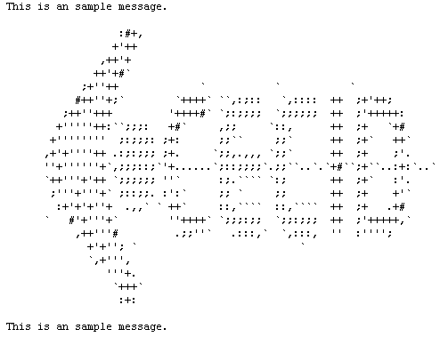

Finally, the test for AS2 plugin installation has been done after executed the above steps successfully.

ebMS Web Service Usage Sample
You are required to execute section 4.3.2 successfully before executing the following ebMS web service usage sample. Next we illustrate the steps to run the test described in section 4.4

Send message to the local Hermes 2 server
ebms-send
This program creates and sends the request attached with payload named " testpayload" under the directory "/config/ebms-send" to Hermes2.
Upon successful execution, you should be able to see the similar output shown in following:

----------------------------------------------------
EbMS sender web service client
----------------------------------------------------
Initialize Logger ...
Importing ebMS sending parameters ... ./config/ebms-send/ebms-request. xml
Importing ebMS partnership parameters ... ./config/ebms-partnership.xm l
Initialize ebMS web service client...
Adding payload in the ebMS message...
Sending ebMS sending request ...

Sending Done:
----------------------------------------------------
New message id: 20080722-143157-97302@127.0.1.1

Please view log for details ..

Check the sent message

ebms-history

This program retrieves the list of sent/received message from Hermes 2.

----------------------------------------------------
EbMS Message History Queryer
----------------------------------------------------
Initialize Logger ...
Importing ebMS config parameters ... ./config/ebms-history/ebms-request.xml
Initialize ebMS messsage history queryer ...
Sending ebMS message history query request ...

Sending Done:
----------------------------------------------------
----------------------------------------------------
EbMS Message Query Result
----------------------------------------------------
0 | Message id : 20080722-143157-97302@127.0.1.1 | MessageBox: outbox
1 | Message id : 20080722-143157-97302@127.0.1.1 | MessageBox: inbox
----------------------------------------------------

Select message (0 - 1), -1 to exit:

Enter 0 to check the sent message, the screen similar as follow will show:

Sending Done:
----------------------------------------------------
Query Message ID : 20080722-143157-97302@127.0.1.1
Query Message Status : DL
Query Message Status Desc : Message was sent.
ACK Message ID : null
ACK Message Status : null
ACK Message Status Desc : null

----------------------------------------------------

Please view log for details ..

Check the received message, download the payload

From the select message screen of ebms-history, enter 1 to select the inbox message, then it will prompt for “Please provide the folder to store the payload(s):”, press enter to save in the current folder. Then there should a file named “ebms.<timestamp>@127.0.1.1.Payload.0”, where <timestamp> is the time you just execute ebms-send before. Open that file and you will see the follow content:

Finally, the test for ebMS plugin installation has been done after executed the above steps successfully.

Configuration for Secure Messaging & Secure Channel

In order to store private key for message signing, keystore is needed. Under current implementation, only PKCS12 keystore is supported.
If you are running Hermes Installer, there are keystore files put under folder called “security”

under both ebMS and AS2/AS2 Plus plugins.

Message Signing
To enable message signing, please configure the plugin with corresponding keystore. A default keystore setting are set through the installer. Or make a new customized keystore. To learn more about generating a keystore, please refer to article about “Generate Certificate”.

Article on “Generate Certificate”:
http://community.cecid.hku.hk/index.php/product/article/configuration_for_message_signning_and_secure_channel/#generate_cert

Sender Setting for Message Signing
To instruct Hermes to perform message signing with correct private-key, the corresponding Keystore Manager should be configured with correct parameters.

ebMS Sender-SideSetting
Open the configuration file named “ebms.module.xml”, which is placed in the conf folder of ebMS plugin. A component named “keystore-manager-for-signature” is defined to manage the keystore.
<component id="keystore-manager-for-signature"
name="Key Store Manager for Digital Signature">
<class>hk.hku.cecid.piazza.commons.security.KeyStoreManager</class>
<parameter name="keystore-location" value="/corvus/plugins/hk.hku.cecid.ebms/security/corvus.p12" />
<parameter name="keystore-password" value="password" />
<parameter name="key-alias" value="corvus" />
<parameter name="key-password" value="password" />
<parameter name="keystore-type" value="PKCS12" />
<parameter name="keystore-provider" value="org.bouncycastle.jce.provider.BouncyCastleProvider" />
</component>

AS2/AS2 Plus Sender-Side Setting
Open the configuration file named “as2.module.core.xml”, which is placed in the conf folder of AS2/AS2 Plus plugin. A component named “keystore-manager” is defined to manage the keystore.
<component id="keystore-manager"
name=" AS2 Key Store Manager">
<class>hk.hku.cecid.piazza.commons.security.KeyStoreManager</class>
<parameter name="keystore-location" value="corvus.p12" />
<parameter name="keystore-password" value="password" />
<parameter name="key-alias" value="corvus" />
<parameter name="key-password" value="password" />
<parameter name="keystore-type" value="PKCS12" />
<parameter name="keystore-provider" value="org.bouncycastle.jce.provider.BouncyCastleProvider" />
</component>

Here are descriptions of parameters.
keystore-location | Absolute file path pointed to keystore file.
keystore-password | Pass phrase to get access to keystore.
key-alias | Name of the private key stored.
key-password | Pass phrase to retrieve the private key.  (PKCS12 standard: key-password is equal to key-password)
keystore-type | The type of the keystore.  PKCS12 (MUST)
keystore-provider | The class provider to handle the keystore.  org.bouncycastle.jce.provider.BouncyCastleProvider

Receiver Setting for Message Signing
For receiver to verify the signature, a public certificate should be provided by the sender through the partnership maintenance page.

After that, set the value of "Signing Required" to "true". For detail setting of the partnership, please refer to as2 partnership reference or ebMS partnership reference.

AS2 partnership reference: http://community.cecid.hku.hk/index.php/product/article/reference_of_as2_partnership_configuration/
ebMS Partnership reference:
http://community.cecid.hku.hk/index.php/product/article/reference_of_ebms_2_0_partnership_configuration/

Message Tranfer with Secure Channel
To further ensure security of message transfer, secure channel is preferable. For more detail on the configuration that have to do, please visit our community site for the article “Configuration for Message Signning and Secure Channel”
.

Article “Configuration for Message Signning and Secure Channel”: http://community.cecid.hku.hk/index.php/product/article/configuration_for_message_signning_and_secure_channel/#send_msg_thur_https

FAQ

Hermes 2 Deployment
Q1.From the corvus.log show,
hk.hku.cecid.piazza.commons.spa.PluginException: Error in processing activation by handler:
hk.hku.cecid.ebms.spa.EbmsProcessor which is caused by java.io.IOException: exception decrypting data - java.lang.SecurityException: Unsupported keysize or algorithm parameters
A1. Please check whether the Java 2 SDK is patched by JCE or not.
Q2. From any one of logs show: hk.hku.cecid.piazza.commons.dao.DAOException: Unable to begin transaction.
A2. Please check whether:
PostgreSQL OR MySQL OR Oracle was installed properly.
AND
Check the following file(s):
For AS2
plugins\hk.hku.cecid.edi.as2\conf\hk\hku\cecid\edi\as2\conf\as2.module.core.xml under Hermes 2 installation directory. There have a tag named “parameter” with attribute “name=url” and check the “value” attribute to see whether it is reference to the correct server address. The format of the value attribute is the same as the JDBC connection string.
For ebMS
plugins\hk.hku.cecid.ebms\conf\hk\hku\cecid\ebms\spa\conf\ebms.module.xml under Hermes 2 installation directory. There have a tag named “parameter” with attribute “name=url” and check the “value” attribute to see whether it is reference to the correct server address. The format of the value attribute is the same as the JDBC connection string.

Web Service Usage Sample
Q1. Exception in thread "main" java.lang.UnsupportedClassVersionError: xxx (Unsupported major.minor version 49.0)

A1. It is very likely you are using an incompatible java version. The web service usage sample requires J2SE 5.0 or above for running properly. In command prompt, enter “java –version” to see whether you are using J2SE 5.0 or above.
Q2. Sending ebMS/AS2 sending request ...
ck messages toava.net.ConnectException: Connec: connect
A2. Check whether the Application Container (Tomcat) has been started up or not.

Reference

Java 2 SE SDK version 5.0: http://java.sun.com/j2se/1.5.0/index.jsp
Java 2 SE SDK version 1.6: http://java.sun.com/javase/6/
Java cryptography extension: http://java.sun.com/products/jce/
Download java cryptography extension for J2SE 5.0: http://java.sun.com/j2se/5.0/download.html
Apache Tomcat version 5.5 / 6.0: http://tomcat.apache.org/
Apache Tomcat version 5.5 Realm Configuration Guideline: http://tomcat.apache.org/tomcat-5.5-doc/realm-howto.html
Apache Tomcat version 6.0 Realm Configuration Guideline:
http://tomcat.apache.org/tomcat-6.0-doc/realm-howto.html
Postgres database version 8.0: http://www.postgresql.org/
MySQL database version 5.0: http://www.mysql.com
Oracle database version 9i: http://www.oracle.com

Create Oracle database: http://www.peacetech.com/flipper/oracle9i/901_doc/server.901/a90117/create.htm

Center for E-Commerce Infrastructure Development: http://www.cecid.hku.hk/

